**Speel Lake Sockeye Salmon Escapement Goal Review 2019**

**29 January 2020**

**Sara Miller, Steve Heinl, Julie Bednarski, Rich Brenner**

Speel Lake is located on mainland Alaska, in Speel Arm, Port Snettisham, approximately 50 km southeast of Juneau. The lake supports a small run of sockeye salmon, which is harvested primarily in the District 11 commercial drift gillnet fishery in Taku Inlet, Stephens Passage, and Port Snettisham. Management of the District 11 fishery is based primarily on the abundance of wild Taku River sockeye and coho salmon, as specified in the Pacific Salmon Treaty, and the Speel Lake sockeye salmon run accounts for a very small portion of the harvest. Since the late 1990s, wild Speel Lake sockeye salmon have also been harvested in terminal hatchery fisheries conducted in Speel Arm to harvest Snettisham Hatchery sockeye salmon runs. Hatchery production is managed in accordance with the *District 11: Snettisham Hatchery Salmon Management Plan* (5 AAC 33.378), which requires ADF&G to conduct common property harvests in the special harvest area (in Speel Arm) by limiting time and area through emergency order authority to protect and sustain production of wild sockeye salmon runs. Speel Lake sockeye salmon harvests have been estimated annually since 1986 (except 1991) in conjunction with U.S./Canada stock identification programs to allocate harvests in the District 11 drift gillnet fishery. Escapements have been enumerated annually at an adult counting weir at the outlet of the lake in all but two years since 1983 (the weir has been operated by Douglas Island Pink and Chum, Inc. since 1996). Weir counts during most of the 1980s and 1990s underestimated the escapement, however, due to early removal of the weir (Heinl et al 2014).

The Speel Lake sockeye salmon run was managed for informal escapement goals of 10,000 sockeye salmon in the 1980s and 5,000 sockeye salmon starting in 1992. In 2003, ADF&G established a biological escapement goal of 4,000–13,000 sockeye salmon, the range of escapements estimated to provide at least 80% of maximum sustained yield (MSY) (Riffe and Clark 2003). The current sustainable escapement goal range of 4,000–9,000 sockeye salmon was established in 2015 based on a spawner-recruit analysis of total runs from 1983 to 2011 (Heinl et al. 2014). A Bayesian age-structured state-space model was used to assess uncertainty introduced by serial correlation, measurement error in escapement estimates (expanded historical weir counts), and missing data (two years of missing escapement data (1993, 1994); four years of missing harvest data (1983–1985, 1991); six years of missing age composition data (1983–1985, 1991, 1993, 1994)). The escapement expected to produce maximum sustained yield (*S*MSY) was estimated to be 6,200 spawners (95% credible interval [CI] 3,900–21,000 spawners), and at the lower bound of the escapement goal range (4,000 spawners), there was an estimated 73–91% probability of achieving at least 80% of MSY.

**Escapement Goal Review:** For this review, the model was updated to include run years 2012–2019. Model parameter estimates were very similar to those reported by Heinl et al. (2014); for example, *S*MSY = 5,900 fish (95% CI = 3,900–12,800 fish) for the revised analysis vs. *S*MSY = 6,200 fish (95% CI = 3,900–21,000 fish) for Heinl et al. (2014). The range of escapements estimated to produce at least 90% of MSY is 3,792–8,156 fish, nearly identical to the current escapement goal range of 4,000–9,000 fish; although shifted a bit lower. Estimated model parameters and management reference points are imprecise for this stock, as indicated by large credible intervals (Table 1). At the current lower bound of 4,000 fish, there is an 81–95% probability of achieving greater than 80% of MSY (Figure 1) and there is a 56–85% probability of achieving greater than 90% of MSY.

The median estimate of ln(*a*) was low at 1.24, corresponding to median productivity (recruits per spawner in the absence of density effects) of *a* = 3.45; but, the uncertainty was high (CV = 0.39 for *a*) (low productivity stock defined as *a* ≤ 4; Su and Peterman 2012). The median estimate of the density dependent parameter ** was 9.38 x 10-5, and the uncertainty was also high (CV = 0.41) (Table 1). Uncertainty about ** is reflected in variability in the values of *S* leading to maximum recruitment *S*MAX = 1/**, and uncertainty about equilibrium abundance, *S*EQ, is reflected by variability in the values of *S* where the curves intersect the replacement line (Figure 2). There is high contrast in the spawner data (contrast = 9; 16,104 spawners in 1990 and 1,788 spawners in 2008) and a few production-to-spawner ratios are below 1.0 at high levels of spawning abundance (escapements > 10,000 fish; years 1983, 1990, 1992).

* Escapements were within the escapement goal range in 9 of the past 10 years (2010–2019; ­2017 was below the range); however, escapements averaged 5,200 fish, all within a narrow range of 3,500–6,500 fish, and all escapements were less than the mid-point of the escapement goal range (6,500 fish) in the last 10 years (Figure 3a; Figure 4). As a result, the addition of 8 years of spawner–recruit data resulted in little change compared to the previous (Heinl et al. 2014) analysis. It could be beneficial to future assessments if escapements were allowed to reach or exceed the upper bound of the escapement goal range (> 9,000 fish) and provide additional testing of density dependence
* Productivity:
  + Ricker recruitment residuals (productivity residuals) are deviations in recruitment from that predicted by the Ricker spawner-recruit relationship. After controlling for density-dependent effects, these deviations reflect time-varying changes in productivity. There does not appear to be a decrease in productivity in recent years, rather productivity seems to be fluctuating in a random manner (Figure 5 and Figure 6b).
  + Estimated harvest rates since 2011 have averaged lower than in the previous decade (Figure 3b), yet escapements have not improved (Figure 3a).

**Escapement Goal Recommendation:** The escapement goal recommendation is to maintain the current sustainable escapement goal range of 4,000–9,000 fish, counted annually at the Speel Lake weir.

**References Cited**

Heinl, S. C., S. E. Miller, and J. A. Bednarski. 2014. Speel Lake sockeye salmon stock status and escapement goal review. Alaska Department of Fish and Game, Fishery Manuscript Series No. 14-04, Anchorage.

Riffe, R., and J. H. Clark. 2003. Biological escapement goal for Speel Lake sockeye salmon. Alaska Department of Fish and Game, Division of Commercial Fisheries, Regional Information Report No. 1J03-04, Juneau.

Su, Z. and R. M. Peterman. 2012. Performance of a Bayesian state-space model of semelparous species for stock-recruitment data subject to measurement error. Ecological Modelling 224, 76-89.

**Table 1.**–*Parameter estimates from the state-space model fitted to the Speel Lake sockeye salmon data for calendar years 1983–2019. Posterior medians are point estimates; the 2.5th and 97.5th percentiles define 95% credible intervals for the parameters.*

|  |  |  |  |
| --- | --- | --- | --- |
| **Parameter** | **2.5th Percentile** | **Median** | **97.5th percentile** |
| ** | 1.95 | 3.45 | 7.31 |
| ln(**) | 0.67 | 1.24 | 1.99 |
| ln(**)’ | 0.80 | 1.36 | 2.23 |
| ** | 3.08 x 10-5 | 9.38 x 10-5 | 1.83 x 10-4 |
| ** | -0.21 | 0.28 | 0.74 |
| **R | 0.35 | 0.46 | 0.63 |
| *S*EQ | 10,504 | 14,782 | 29,740 |
| *S*MAX | 5,452 | 10,666 | 32,515 |
| *S*MSY | 3,916 | 5,946 | 12,824 |
| *U*MSY | 0.36 | 0.55 | 0.77 |
| D.sum | 10 | 17 | 28 |
| *p*4 | 0.32 | 0.37 | 0.41 |
| *p*5 | 0.56 | 0.60 | 0.65 |
| *p*6 | 0.02 | 0.03 | 0.04 |
| B.sum | 4 | 7 | 12 |

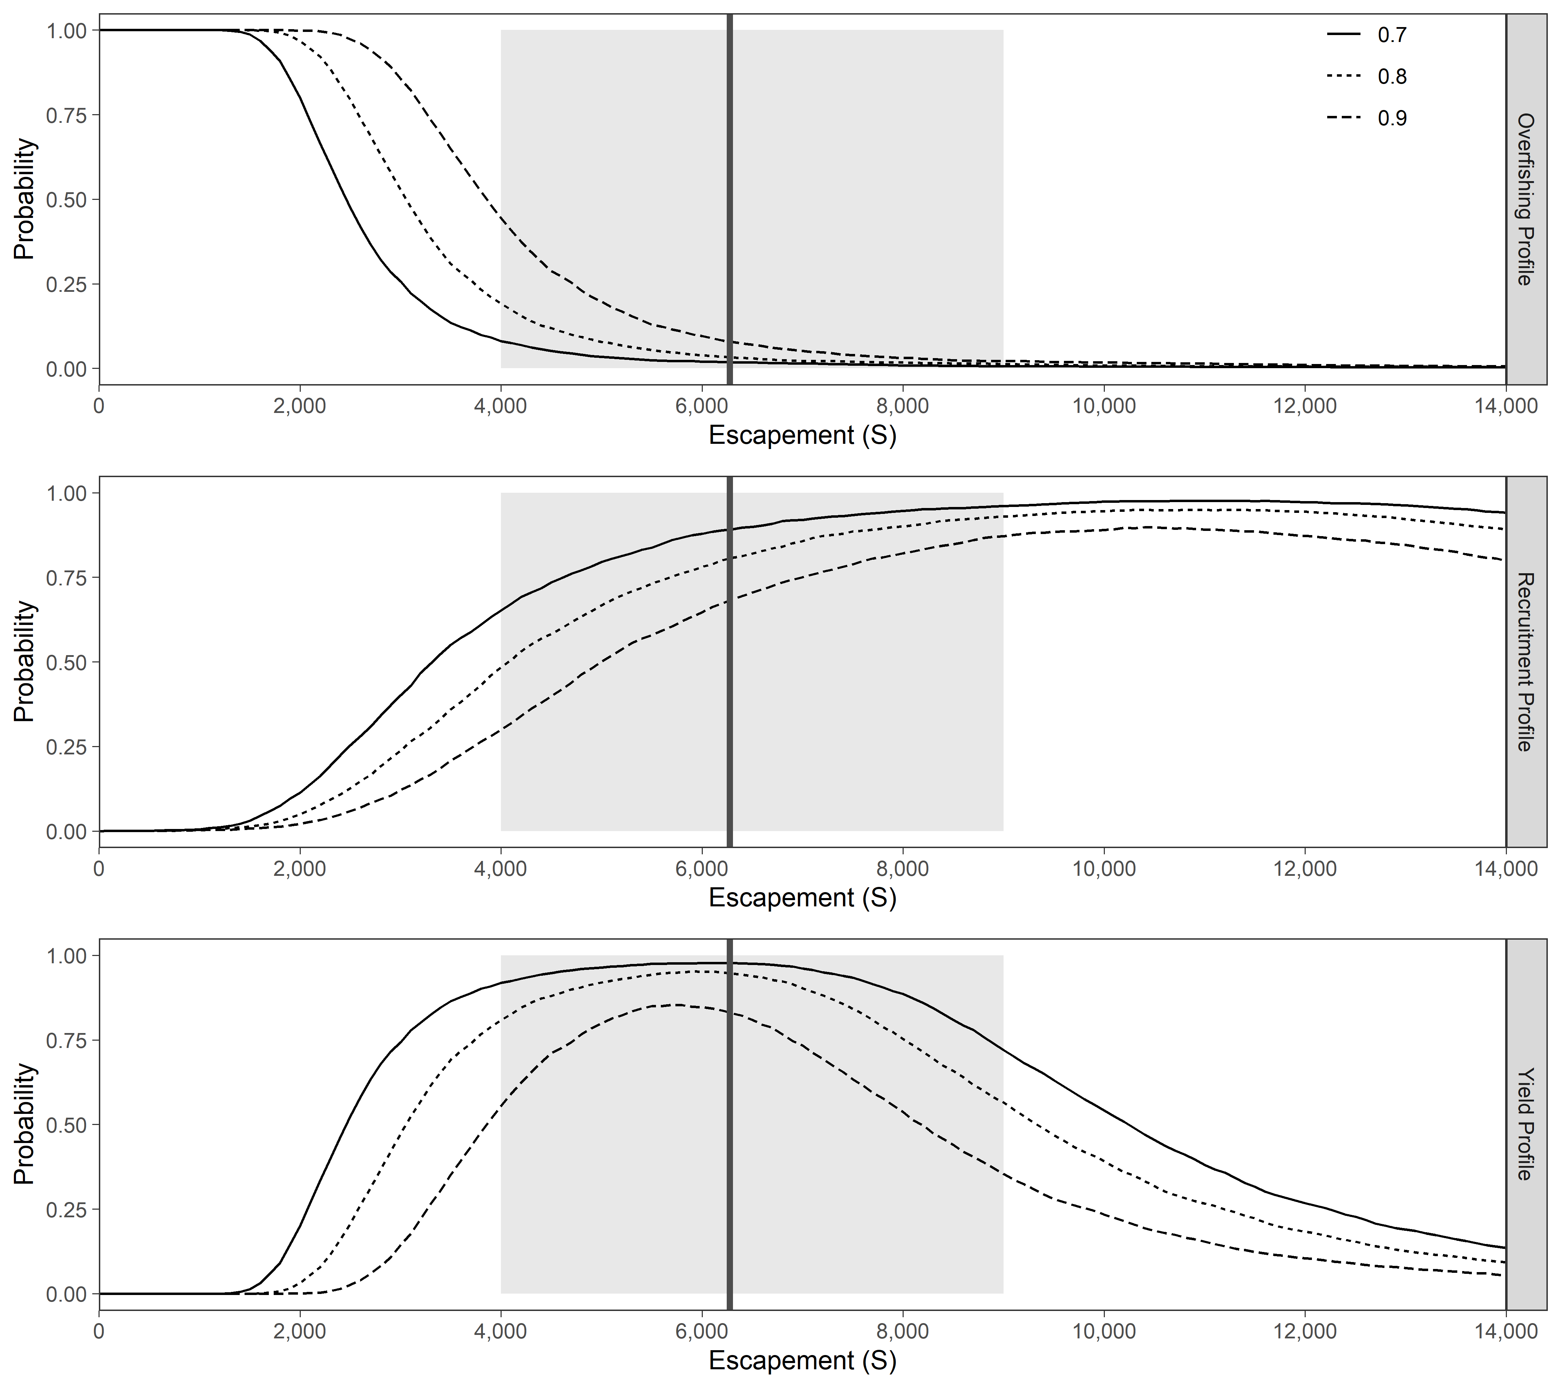

**Figure 1.**–*Overfishing profiles (OFPs), optimal recruitment profiles (ORPs), and optimal yield profiles (OYPs) for Speel Lake sockeye salmon. OYPs and ORPs show probability that a specified spawning abundance will result in specified fractions (70%, 80%, and 90% line) of maximum sustained yield or maximum recruitment. OFPs show the probability that reducing escapement to a specified spawning abundance will result in less than specified fractions of maximum sustained yield. The shaded region shows the current sustainable escapement goal range of 4,000 to 9,000 spawners and the solid vertical line is the posterior median of spawning abundance at maximum sustained yield (SMSY) obtained from the state-space model.*

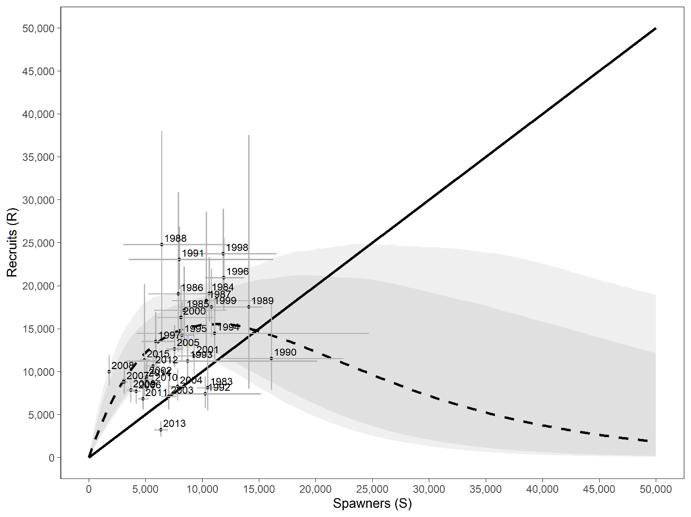

**Figure 2.**–*Plausible spawner-recruit relationships (shaded regions around the dashed line) for Speel Lake sockeye salmon as derived from a Bayesian state-space model fitted to abundance, harvest, and age data for calendar years 1983–2019. Posterior medians of recruits and spawners are plotted as brood year labels with 95% credible intervals (grey lines). The heavy dashed line is the Ricker relationship constructed from ln(α’) and β posterior medians with 90% and 95% credible intervals (shaded areas). Recruits replace spawners on the solid diagonal line.*

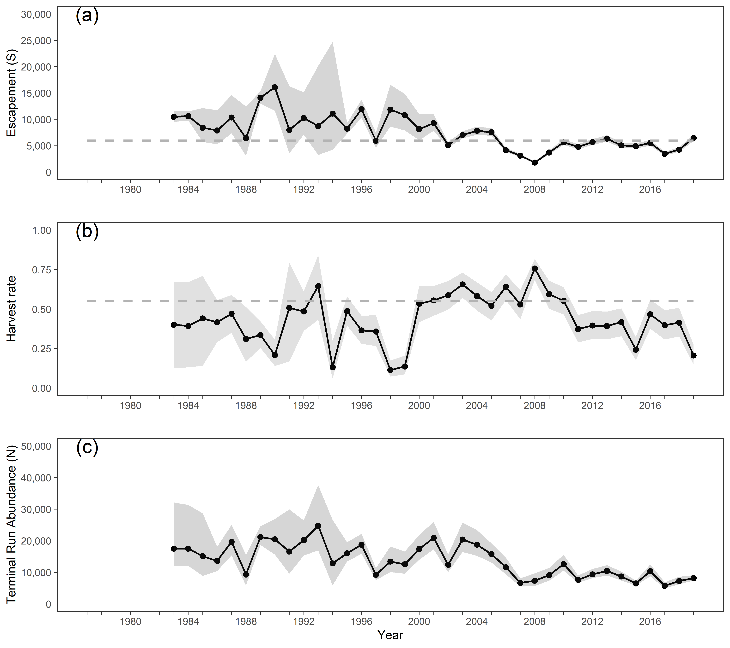

**Figure 3.**–*Point estimates (posterior medians; circles with solid lines) and 95% credible intervals (gray shading) of (a) spawning escapement, (b) harvest rate, and (c) run abundance from the state-space spawner-recruit model of Speel Lake sockeye salmon, 1983–2019. Posterior medians of optimal escapement, SMSY, and harvest rate, UMSY, are plotted as dashed horizontal reference lines in (a) and (b), respectively.*

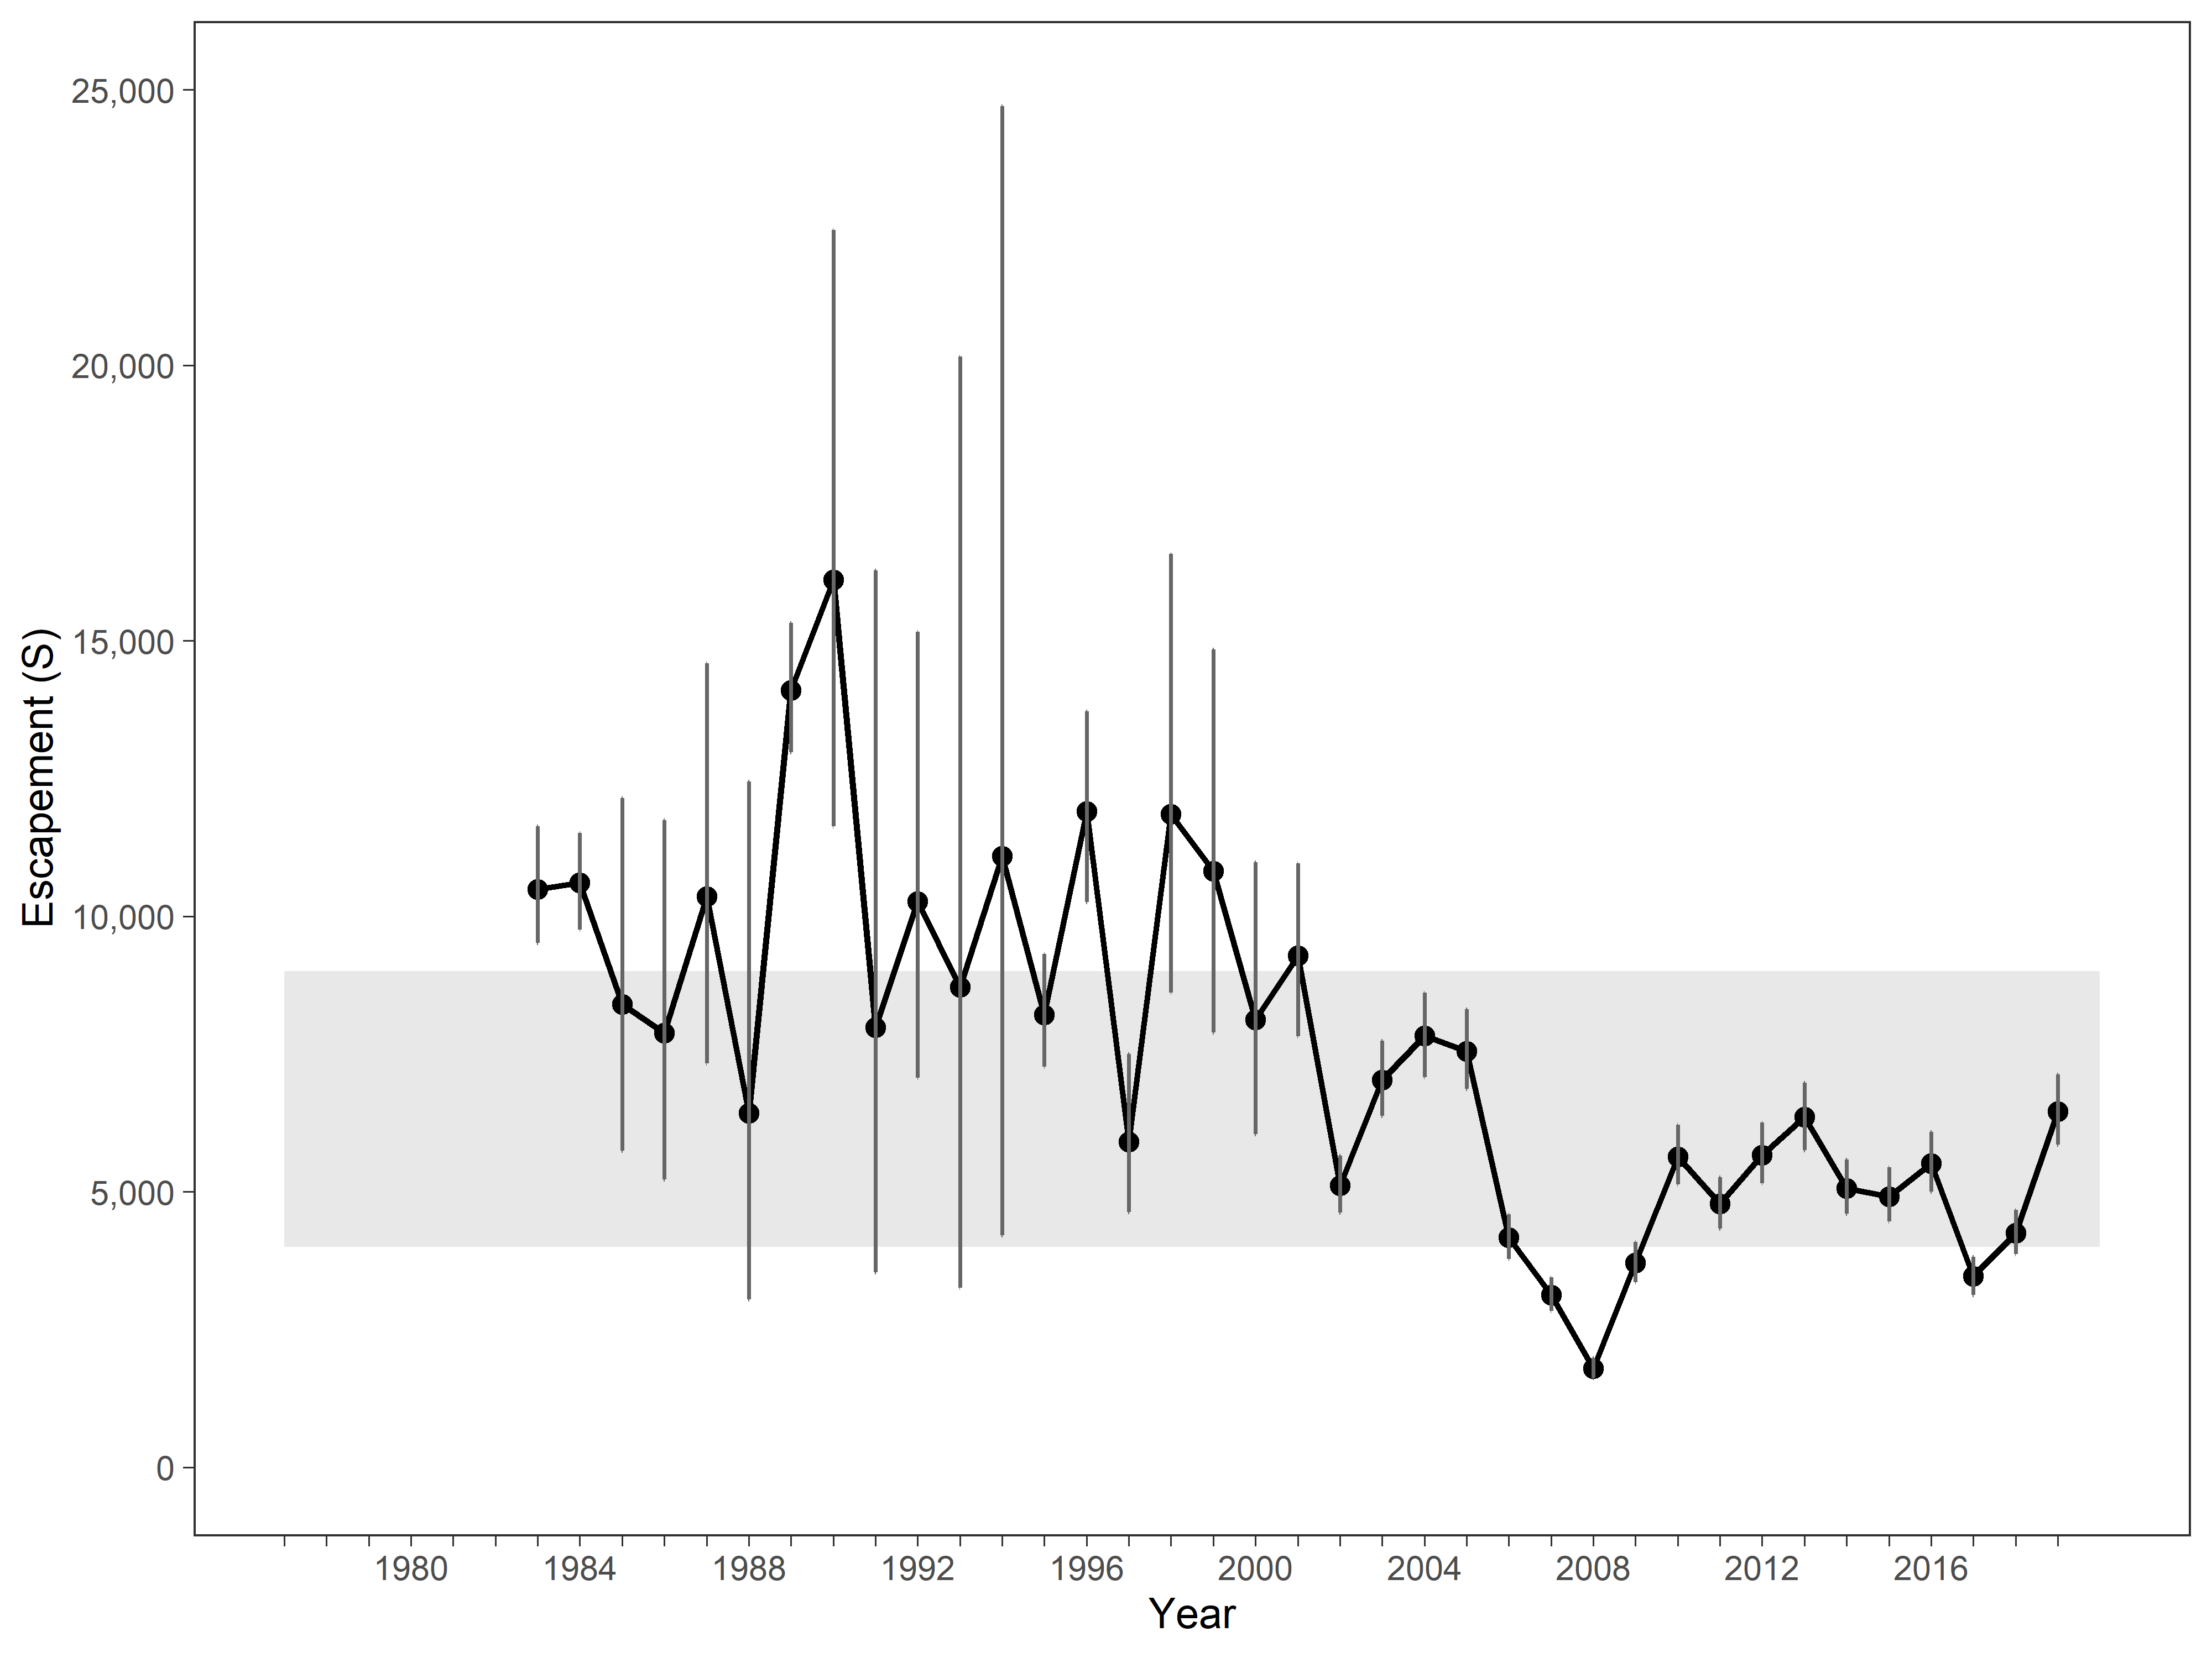

**Figure 4.**–*Posterior medians of escapement estimates (spawners (S)) and 95% credible intervals (vertical lines obtained by fitting a Bayesian state-space model to Speel Lake sockeye salmon data,* *1983–2019. The grey shaded region represents the current escapement goal range of 4,000–9,000 fish.*

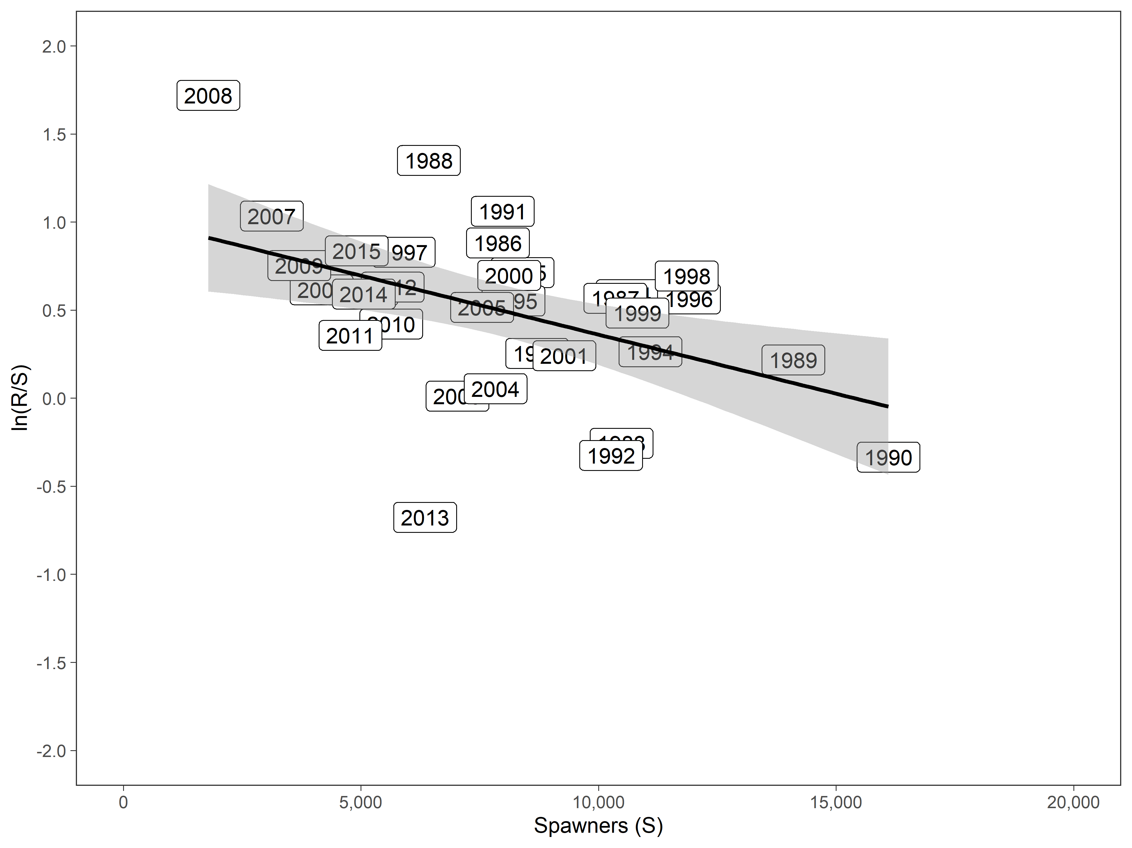

**Figure 5.**–*Natural logarithm of recruits per spawner vs spawners for Speel Lake sockeye salmon,* brood years *1983–2015.*

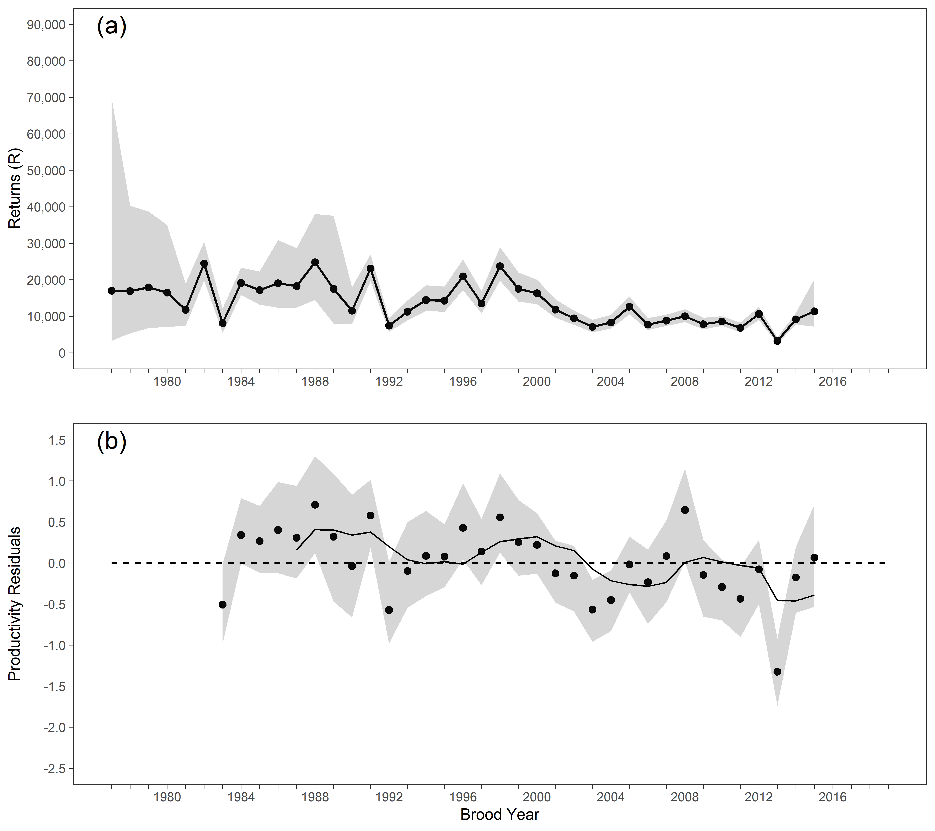

**Figure 6.**–*Point estimates (posterior medians; circles with solid lines) and 95% credible intervals (shaded areas) of (a) recruitment and (b) productivity residuals by brood year from the Bayesian state-space model for Speel lake sockeye salmon.* *A 5-year rolling mean is shown as a solid black line in (b).*